**“Automatic Street Light Control”**

Electrical Department, AISSMS IOIT Pune, India.

***Abstract****— The 21st century is striving hard to save electrical energy. Street lights are essential, but expensive, therefore there is need to optimize the system in a way that it is affordable and efficiently conserves energy. Manually controlling the street lights is a time taking and tedious process. These lead to wastage of electricity and at the same time a manual control is not effective in the modern era. In this paper, we purpose an advanced light control system which is capable of replacing the old generation light control system. The system is implemented on an embedded platform & is equipped with a photo sensitive detector (LDR) which gives the required input for operation .The working of our light control system is based on the amount of luminous energy in the environment at that moment of time. Depending upon the light intensity at that instant the lighting of the lighting system is adjusted. The embedded main board including the Microcontroller chip, memory (flash), and communication port are used as a processing module for the input that we get from peripheral devices (LDR).Application of such a system can be implemented in workstations, park lights, street lighting system, head lights of automobiles and much more.*

*Present paper describes a model, which is done by using several software’s like proteus python IDE and many more.A prototype of the proposed automatic street light control system is built and tested to analyze the performance of the system.*

***Keyword- IDE (Integrated development environment), LDR(light dependent resistor), PWM (pulse width modulation)***

**I. INTRODUCTION**

The man-made light sources have only two modes of operation that is switch on and switch off there is no intermediate level that can be set according to the surrounding lighting condition and at the end everything needs to be controlled manually. The main problem that manual controls on the street lights face is that there would be a lot time taking during evening times when they are to be switched ON and a significant waste of energy is done at morning at all could not be turned OFF together at once.

In proposed System we implemented a smart Street light control method which will same a lot energy at midnight and at morning/ less traffic time. Light detector sensors and infrared sensors are used to determine weather it is day time or night. Special PWM (pulse Width modulation) technique is used to control street light intensity to save energy at night time..

A system which reduces manual control and would efficiently save energy. This could be done by using low power, robust and efficient components.

**II. BLOCK DIAGRAM AND DESCRIPTION.**

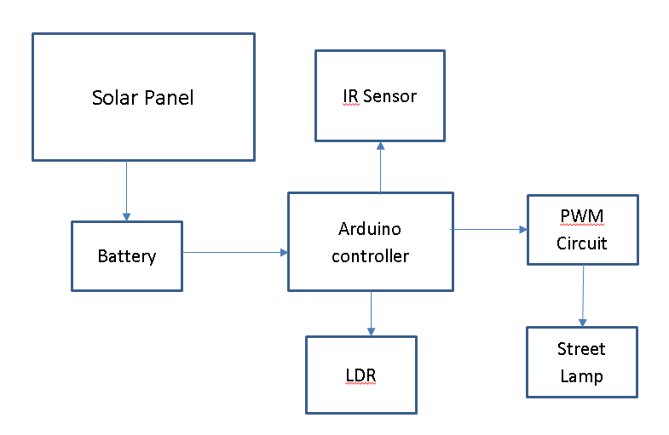

**Fig 2.1: Block diagram of Model**

* Solar panel- Photovoltaic solar panels absorb sunlight as a source of energy to generate electricity. A photovoltaic module is a packaged, connected assembly of typically 6x10 photovoltaic solar cells.
* IR(Infrared Sensor)- A passive infrared sensor is an electronic sensor that measures infrared light radiating from objects in its field of view. They are most often used in IR-based motion detectors.IR sensors are commonly used in security alarms and automatic lighting applications
* LDR(Light Dependant resistor)- A photo-resistor is a light-controlled variable resistor. The resistance of a photo-resistor decreases with increasing incident light intensity; in other words, it exhibits photoconductivity. A photo-resistor can be applied in light-sensitive detector circuits, and light-activated and dark-activated switching circuits.

* PWM Circuit – a transistor based PWM circuit is designed to switch on/ off street light at very fast rate to control the intensity of street light.
* Power Supply- 5v 1amp on board linear power supply is designed which will be directly power up from main and will be sufficient to run all components on the board.

**III. CIRCUIT CONFIGURATION**

**SOFTWARE INFORMATION**

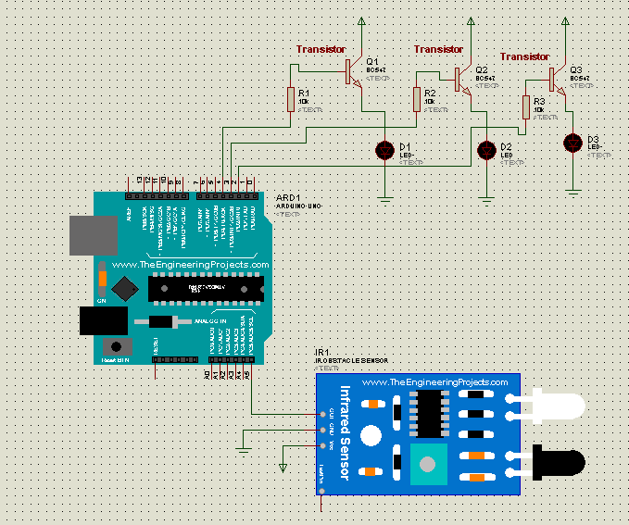

* Simulation software

Proteus V2.0

developed by lab centre electronics

released in 1988,England.

thousands of electronics component library provided.

**Fig 3.1:** Simulation Prototyping.

[A]: Model Simulation.

Basic system module is designed on proteus simulation environment for basic module and programming testing, software description are explained as in same section.

Arduino Uno is the main controller board. All the other peripheral modules and sensors are connected to it as shown in simulation fig. 3.1. As shown the led drivers transistor base are attached to the GPIO(general purpose Input/output) of Arduino uno. Which will be controlled by the Arduino as it programmed.

IR sensor and LDR sensors are connected to Analog. Digital pins of Arduino board as shown in picture. Based on the received data it will adjust the PWM and intensity of street light.

**IV. Hardware modules.**

Prototype Module is built after circuit simulation and designing is done as shown in fig 3.2.1 by using software simulations result. Prototype module important parts/components are explained as b

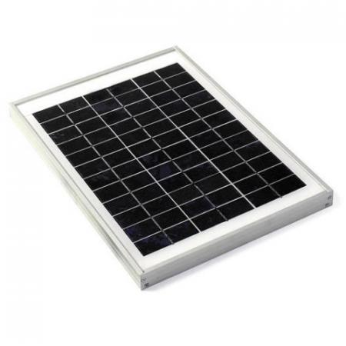

**Fig 3.3.1: Solar Plate.**

Module 1: Solar Plate.

Solar power is the conversion of energy from sunlight into electricity, either directly using photo voltaic, indirectly using concentrated solar power, or a combination. Concentrated solar power systems use lenses or mirrors and tracking systems to focus a large area of sunlight into a small beam.

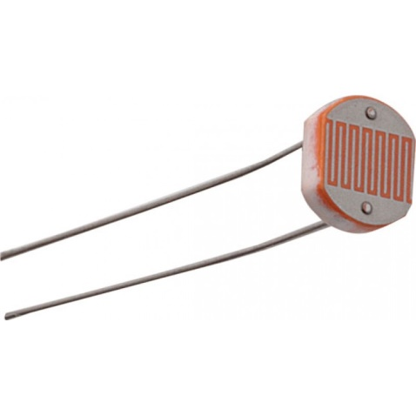

**Fig 3.3.2: LDR (Light dependent resistor).**

Module 2: LDR sensor.

A photo resistor is a light-controlled variable resistor. The resistance of a photo resistor decreases with increasing incident light intensity; in other words, it exhibits photoconductivity. A photo resistor can be applied in light-sensitive detector circuits, and light-activated and dark-activated switching circuits.

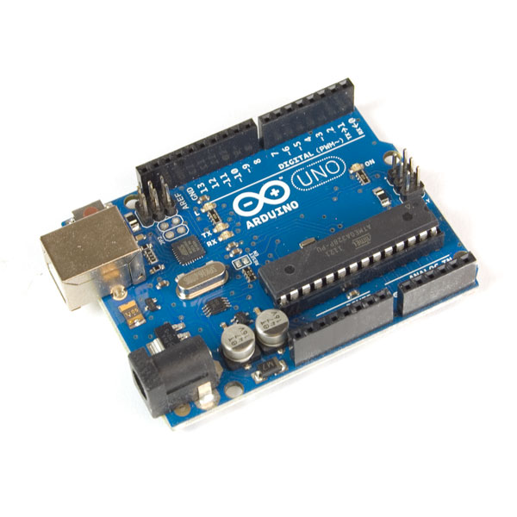

**Fig 3.3.3: Arduino Uno.**

Module 3: Arduino Uno

The Arduino UNO is an open-source microcontroller board based on the Microchip ATmega328P microcontroller and developed by Arduino.cc. The board is equipped with sets of digital and analog input/output pins that may be interfaced to various expansion boards and other circuits

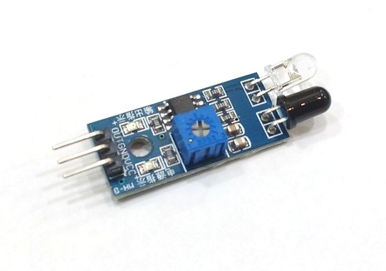

**Fig 3.3.4: Infrared Sensor.**

Module 3: Infrared Sensor.

Infrared sensor works on infrared sensing. It transmit the infrared rays and the rays reflect back from object. If any moment happens then that pattern get disturbed and motion/object is detected.

**VI. CONCLUSION**

* By introducing such a reliable system human intervention is reduced and efficient job management is done. Power saving is also another concern which will be maintained by system itself. The proposed street light control system helps in power saving and a centralised control. Depending on line intensity street lights are adjust in night time so power saving can be done efficiently.

**VII. REFERENCES**

[1] Y. K. Tan; T. P. Huynh; Z. Wang,” Smart Personal Sensor Network Control for Energy Saving in DC Grid Powered LED Lighting System”, IEEE Trans. Smart Grid

[2] O’Reilly, Fergus, and Joe Buckley. "Use of wireless sensor networks for fluorescent lighting control with daylight substitution." Proceedings of the Workshop on Real-World Wireless Sensor Networks (REANWSN). 2005.

[3] 1. M Popa, C Cepisca. Energy consumption saving solutions based on intelligent street lighting control system. U P B Sci Bull, 73:297-308, 2011.

[4] Schwab R N, Walton N E, Mounce J M and Rosenbaum M J. Synthesis of safety research related to traffic control and roadway elements. Volume 2, Chapter 12, Highway Lighting. Report No. FHWA-TS-82233. Federal Highway Administration, 1982.

[5] Divya, Guddeti, et al. "Design and Implement of Wireless Sensor Street Light Control and Monitoring Strategy along with GUI." IJITR (2016): 78-81.

[6] Prasetyo, William Tandy, Petrus Santoso, and Resmana Lim. "Adaptive Cars Headlamps System with Image Processing and Lighting Angle Control." Proceedings of Second International Conference on Electrical Systems, Technology and Information 2015 (ICESTI 2015). Springer Singapore, 2016.